
2015 Ford 2.7L EcoBoost V6 Engine Tested with Tier 2 Fuel HD1 – NCAT Test Report

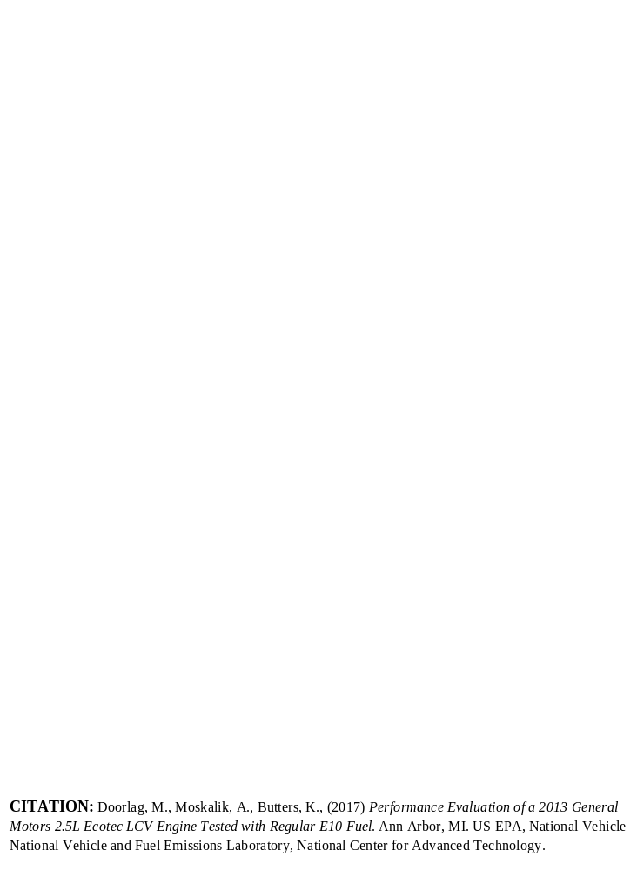
SUGGESTED CITATION: 2015 Ford 2.7L EcoBoost V6 Engine Tier 2 Fuel HD1 – Test Data Package. Version 2019-11. Ann Arbor, MI: US EPA, National Vehicle and Fuel Emissions Laboratory, National Center for Advanced Technology, 2019.
NCAT – National Center for Advanced Technology

National Vehicle and Fuel Emissions Laboratory – Office of Transportation and Air Quality
U.S. Environmental Protection Agency

November 25, 2019

Brian Olson

Dated: 11-25-19

Table of Contents
Purpose of Test 3
Definitions 3
Description of Test Article 3
Test Site 4
Test Cell Capabilities 5
Data Collection Systems 5
Engine Setup and Systems 6
Test Methodology 7
Test Fuel 7
Quality Procedures 8
Engine Safeties 8
Pre-Conditioning and Common Mode Check 8
Test Data Points 9
Test Procedure 10
Intercooler Temperature Control 10
Data Set Processing 10
Data Quality Control 11
Results 12
Uncertainty 13
References 20

Purpose of Test
The purpose of this test was to characterize the performance of a 2015 Ford F150 2WD 2.7L EcoBoost V6 engine, particularly to generate fuel map data that may be used in the ALPHA full vehicle simulation model. This testing followed initial testing conducted in NCAT Test Cell 9 as documented in 2015 Ford 2.7L EcoBoost V6 Engine Tier 2 Fuel Cell 9 – Test Data Package which provided thorough testing data for the main operating portion of the engine map. The equipment and configuration of Test Cell Heavy Duty 1 (HD1) can perform the high speed and high load mapping needed to construct a more complete engine map covering the high speed, high load portion. Steady state data in this package was included as comparison for the more complete steady state testing conducted in NCAT Test Cell 9 and was used to confirm consistent operation of the engine between the two test programs.

Definitions
Fuel map | Engine operating map that displays contours of brake specific fuel consumption (in g/kWh) on a grid of engine speeds (RPM) and engine torques (Nm)
ALPHA model | Advanced Light-Duty Powertrain and Hybrid Analysis tool
Protection mode | An engine operation mode where the ECU retards ignition timing, limits load and/or runs excess fuel (λ<1) due to exhaust temperature limits being reached

Description of Test Article
The engine used in this project was a 2015 Ford F150 2.7L EcoBoost V6, which is a direct-injection gasoline engine. Table 1 summarizes information that describes the vehicle and engine used in this test program.

Table 1: Summary of Vehicle and Engine Identification Information
Vehicle (MY, Make, Model) | 2015 Ford F150 2WD
Vehicle Identification Number | 1FTEX1CP5FFA23506
Engine (displacement, name) | 2.7L EcoBoost V6
Rated Power | 325 hp @ 5750 RPM
Rated Torque | 375 lb-ft @ 3000 RPM
Recommended Fuel | Regular unleaded or E85
Engine Features of Interest | Turbocharged, direct injection, intake and exhaust cam phasing, integrated exhaust manifolds

The engine with its associated controller is subject to manufacturer specific protection modes that are not controllable in the test cell. These protection modes may limit operation of the engine, particularly at higher loads where the engine temperatures can reach critical thresholds.

The objective of this benchmarking was to characterize the engine while operating in an engine dynamometer test cell as though the engine were operating in the vehicle. The engine control unit (ECU) in today’s vehicles requires communication with other control modules to monitor the entire vehicle’s operation (security, entry, key on, dashboard signals, etc.). Because the ECU needs signals from these modules to operate, the signals need to be extended into the test cell, so the ECU can send and receive signals indicating correct vehicle operation. For this benchmark testing, the wiring harnesses were lengthened connecting the ECU in the test cell to the rest of the vehicle. As a result, the engine located in the dynamometer cell was then tethered to its vehicle chassis located outside the test cell. The ECU signals were monitored by the data acquisition system. Figure 1 illustrates the tethered wiring harness.
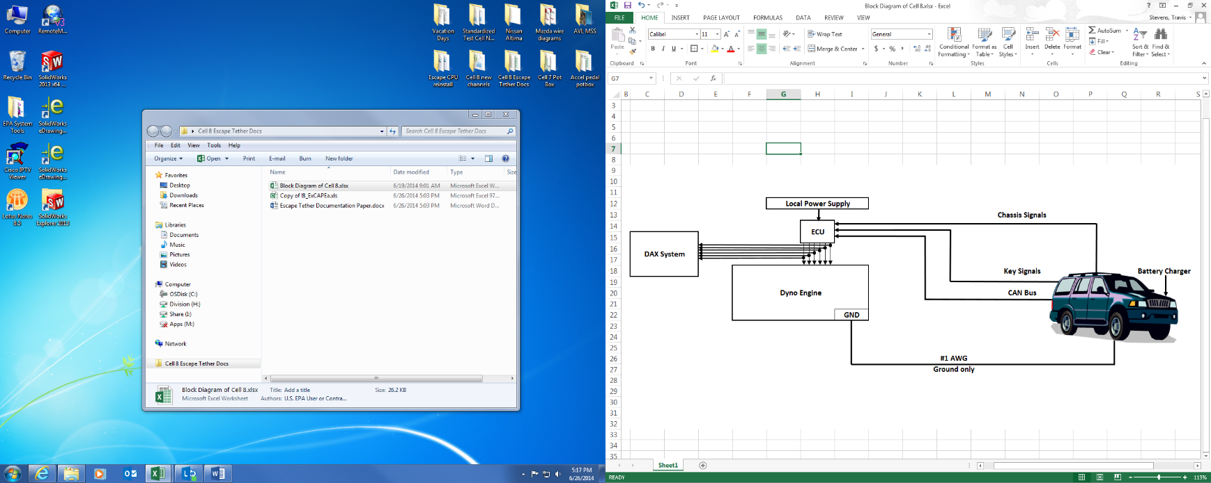
Figure 1. Vehicle and Engine Tethered Wire Harness

Test Site
This test was performed in National Center for Advanced Technology (NCAT) Test Cell Heavy Duty 1 (HD1), but the procedure is applicable to any NCAT test cells using iTest controls and RPECS data collection. Test Cell HD 1 has a higher capacity dynamometer, specifically 600 HP absorption and 6000 RPM speed capability, needed to perform the high speed and high load portion of the engine mapping.

Test Cell Capabilities
The following instrumentation listed in Table 2, exists in Heavy Duty 1 although not all instrumentation listed may have been utilized during this testing.

Table 2: Instrumentation in NCAT Heavy Duty 1
Equipment / Instrument Name | Purpose/Measurement Capabilities | Manufacturer
Dynamometer | Absorb torque from engine and provide motoring torque to engine | General Electric  Boston, MA
Torque Sensor | Measures torque | HBM GmbH,  Darmstadt, Germany
CVS Dilution Tunnel | Exhaust flow system | Horiba  Stuttgart, Germany
Coriolis Fuel Meter | Measures fuel flow rate | Emerson Micro Motion,  St. Louis, MO
Laminar Flow Element | Measures air flow rate | General Electric  Boston, MA

Data Collection Systems
Test cell data acquisition and dynamometer control were performed by iTest, a software package developed by A&D Technology, Inc., Combustion data were analyzed by an MTS Combustion Analysis System (CAS). RPECS-IV (Rapid Prototyping Electronic Control System - IV) is supplemental data acquisition software developed by Southwest Research Institute (SwRI). RPECS directly measures and logs ECU input/output (I/O) along with test cell data. Temperatures, pressures, and test cell data were sent from iTest to RPECS via CAN. The engine control and analysis systems are summarized in Table 3.

Table 3: Engine Control and Data Acquisition Systems
System | Developer | Description | Data Rate
iTest | A&D Technology Inc., Ann Arbor, MI | Test cell automation hardware and software system that controls the dynamometer and some engine controls; collects test cell data; master data logger. | 10-100 Hz
MATLAB | MathWorks, Natick, MA | Software used for development of data processing algorithms for transient testing | --
RPECS | Southwest Research Institute, San Antonio, TX | Crank angle-based engine control and data acquisition system that collects ECU analog and CAN data, TCU analog and CAN data, and controls torque converter lock up solenoid. | 1/engine cycle

Engine Setup and Systems
Figure 2 illustrates the engine configuration and sensor location in the dynamometer test cell. The sensor colors shown in the upper left corner of the figure indicate which systems were monitored.

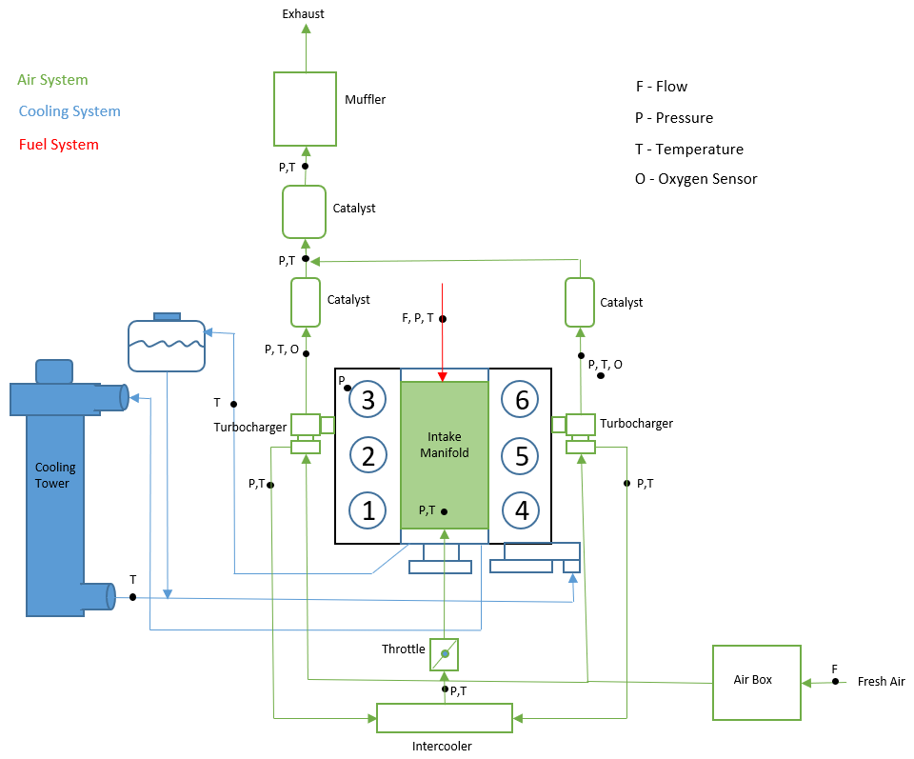
Figure 2: Testing Schematic with Engine Sensor Locations & Monitored Systems

The stock engine systems were used with the addition of instrumentation as follows:
- Intake: The stock air box and plumbing were used.
- Charge air cooling: The stock tubing and intercooler were used. Charge air temperature was cooled by controlling the air flow and temperature flowing through the intercooler fins.
- Exhaust: The stock exhaust system was used including catalyst and mufflers. The exhaust system outlet was connected to the emission tunnel via 2-inch diameter tubing. Emission tunnel pressure was controlled to approximately P^{atm} +/- 1.2 kPa, which is a variation of pressure below the required limits specified within the U.S. Code of Federal Regulations for chassis dynamometer testing.
- Oil system: The engine oil cooler was connected to a chilled water system and controlled to 90°C by the test cell control system.
- Cooling system: The stock cooling system was used, but the radiator was replaced with a cooling tower. The stock engine thermostat was used to control engine coolant temperature and the cooling tower was controlled to 85 °C by iTest.
- Alternator: The alternator was modified for no electrical output by removing the field coils.
- Front End Accessory Drive (FEAD): The serpentine belt was removed for this testing. The water pump was electrically driven and controlled by the ECU. Any losses associated with the FEAD were not included in the final Brake Specific Fuel Consumption (BSFC) or Brake Thermal Efficiency (BTE) maps.
- Flywheel and housing: The engine used a stock manual flywheel with an aluminum adapter plate connected to the dynamometer driveshaft. The flywheel housing was a fabricated housing with mounting pads for the rear mounts.

Test Methodology

Test Fuel
The primary properties of the Tier 2 fuel used in this test program are shown in Table 4 below. A detailed summary of the fuel analysis performed, and results measured for the Tier 2 fuel utilized in the test program can be found in the file: 6- NVFEL Fuel Analysis Report 26864.pdf.

Table 4. Fuel Properties for FTAG 26864
Parameter Description | Test Fuel Specifications  (40 CFR §86.113-04) | Reference Procedure | Measured Results | Units
Research Octane (optional) | 93 (minimum) | ASTM D2699; ASTM D2700 | 97.6 | RON
Octane Sensitivity (optional) | 7.5 | ASTM D2699; ASTM D2700 | 8.6 | RON-MON
Hydrocarbon Composition (vol %)
Olefins | 10% Maximum | ASTM D1319 | 0.6 | Vol %
Aromatics | 35% Maximum | ASTM D1319 | 30.2 | Vol %
Total Sulfur, wt.% | 0.0015-0.008 | ASTM D2622 | 40.0 | ppm
Dry Vapor Pressure Equivalent, psi (kPa) | 8.7–9.2 (60.0-63.4) | ASTM D5191 | 9.07 | psi
The following are provided for Reference Only and are not specified in the CFR
Antiknock | None | N/A | 93.30 | (RON+MON)/2
Net Heating Value | None | ASTM D3338 | 18447 | BTU/lb
Net Heating Value | None | N/A | 42.9 | MJ/kg
Alcohol Content | None | ASTM D5599 | 0.0 | Vol %
Carbon Content | None | ASTM D3343 | 0.86640 | Weight Fraction

Quality Procedures
This test program is covered by the Light-Duty Greenhouse Gas Test Program: Evaluating Potential Future Vehicle Technologies Quality Assurance Project Plan (QAPP).

Engine Safeties
Table 5 lists the limits that exist for several engine parameters. These variables were monitored to ensure component durability and operator safety.

Table 5: Engine Safety Limits
Parameter | Test Parameter Name | Units | Minimum | Maximum
Oil Pressure |  | kPa_{g} | 175
Coolant Temperature | Coolant Temp | ºC |  | 120
Engine Speed | Speed | RPM |  | 6500

Pre-Conditioning and Common Mode Check
Before collecting operating map data, the engine was warmed up. The engine was considered “warm” when the fuel flow rate & exhaust temperatures stabilized, and the coolant and oil temperatures were a minimum of 90 ºC respectively. A common mode, run with the parameters given in Table 6, was repeated at the beginning of each test to expose any potential inconsistencies that could indicate equipment wear or improper instrument calibration. For each common mode, the parameters in Table 7 were examined to check for any deviation from the norm.

Table 6: Common Mode Test Conditions and Criteria for Achieving “Warmed” State
Parameter | Test Parameter Name | Condition
Engine Speed Setting | Speed | 2000 RPM
Pedal Command Setting |  | 50%
Coolant Temperature Criteria | Coolant Temp | 90 ºC
Oil Temperature Criteria | Oil Sump Temp | 90 ºC

Table 7: Common Mode Test Parameters
Parameter | Test Parameter Name | Unit
Brake Mean Effective Pressure | BMEP | Bar
Thermal Efficiency | BTE | %
Intake Manifold Pressure | Intake Manifold Press | kPa
Compressor Out Pressure | Comp Out Press | kPa

Test Data Points

The test data points for this engine map covered the torque and speed range of the engine according to the rated values in Table 1. Two different test procedures were needed to appropriately replicate steady-state engine operation at low/mid loads and transient engine operation at high loads.

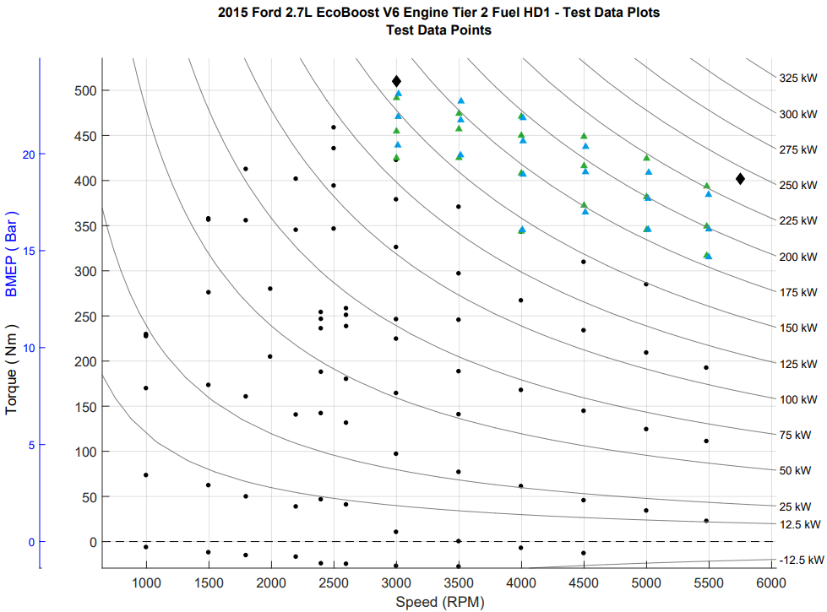

LEGEND
Core Map Steady-State Operating Points
High Load Transient Operating Points - Initial Value
High Load Transient Operating Points - Final Value
Maximum Rated Torque and Power Points (from published data) [1]

Figure 3. Engine Mapping Operating Points

Steady State Operating Points - Steady-state operating points, (black dots in Figure 3), were collected using steady state mapping procedures and were at loads generally below where enrichment was observed in this benchmarking program. The core of the steady state portion of the engine map contains the primary operating range of the engine, which is characterized by stoichiometric operation and spark timing which will result in the highest efficiency. These points generally have stable consistent engine controls (e.g. spark timing, valve timing, start of injection), allow the use of relatively slow response fuel flow measurement systems over a 30-second data collection window, and are therefore straightforward to analyze and report. The steady state test points are an average of 10-hz data over a 10 second window after stable consistent engine control was observed (e.g. spark timing, valve timing, start of injection).

Engine operation consisted of holding the engine at a fixed speed (with the engine dynamometer) and commanding a fixed pedal position. Operation at this point was held until the engine torque, fuel flow, and exhaust temperature reached a stable condition. The data was then logged for 10 seconds at 10 hertz sampling and averaged using iTest. For each engine speed, the sequencing procedure stepped through an array of pedal commands from low to high (0 to 100% pedal position) and recorded the steady-state data for each test data point. The engine speed was then incremented to the next highest rpm and the torque array was repeated.

High Load Transient Operating Points - The high load transient operating points, (blue and green triangles in Figure 3), are defined as the region where enrichment was generally observed. Data were collected with a transient procedure to more accurately characterize the transient nature of the high load engine control, which is employed to protect the engine from excessively high temperatures, avoid preignition at low speed/high load, or avoid knock at high speed/high load. For this phase of testing the engine was operated at high loads near and including wide-open throttle (WOT) using a special test procedure to measure the transient response that occurs when the engine is protecting itself at high loads.

The high load points were identified during the steady state testing when the air/fuel ratio was noted to change from stoichiometric to enriched during its stability and steady-state logging time of approximately 30 seconds. For each transient test point, the accelerator pedal was held at about 1/3 load and the engine was allowed to stabilize. The accelerator pedal was then ramped from 1/3 load to the specified high load in one second. The engine stepped through an array of specified speed and load points in a sequence similar to the steady-state procedure. For each data point, the data were logged continuously at each engine cycle while the engine torque was ramping up to the desired torque value and operation was held at that point for 30 seconds. The data were then post-processed to determine the peak torque, final torque, transition time from stoichiometric to commanded fuel enrichment (could be essentially instantaneous), brake thermal efficiency (BTE), and other key engine criteria.

Test Procedure
The engine and vehicle were tested in the engine dyno cell with a tethered wire harness as described previously. The speed of the engine was controlled by the dyno speed set point. The load of the engine was controlled by the ECU which was set by the vehicle pedal input. The pedal input signal was generated by disconnecting the vehicle’s pedal and replacing it with an iTest controller. The test procedure stepped through an array of data points based upon the specified speed and torques described in the paragraphs above. Stability was determined by fuel flow and torque. The iTest control system logged data from the Horiba MEXA, CAS, RPECS and the engine controller.

The idle fuel flow conditions were not measured in the engine dyno test cell because this engine was not tested with a transmission. The engine was coupled to the dyno with a solid drive shaft which does not allow low speed data operation. For the engine to be in an idle condition, the loads and rotation inertias must be the same as in the chassis using a transmission.

Intercooler Temperature Control
During testing, an important consideration was to maintain temperatures that are representative of real-world usage, where the engine would be cooled by airflow into the engine compartment as vehicle speed increases. Prior chassis testing of the Ford F150 using a road speed fan identified 30-40 ºC as the target intercooler temperature range for this engine. In the dynamometer test cell, cooling airflow was produced by using two fans located at the intercooler and setting the intercooler coolant temperature to 35 °C.

Data Set Processing
Steady State Operating Points - The iTest data collection system logged each single mode at 10 hz for 30 seconds and the data was subsequently averaged and written to the data file. The variable list also included statistical information for selected variables such as standard deviation, coefficient of variation, minimum & maximum. The data logged during testing included torque, fuel flow, emissions, temperatures, pressures, in-cylinder pressure and OBD/epid CAN data. The steady-state data were recorded by the iTest data acquisition system.

High Load Transient Operating Points - The data logged over the 30-second window were divided into “initial” and “final” sections, where the speeds and loads were relatively stable. These sections were of varying lengths, according to their relative stability, but were typically two to five seconds in duration. The data were averaged over these time intervals to create “high load initial” and “high load final” data points.

For all operating points, brake specific fuel consumption (BSFC) in g/kW-hr was calculated according to the equation below using the values obtained from iTest.

 | $$BSFC=\frac{Fuel Flow}{Torque*Speed*\left(\frac{2π}{60}\right)}3.6*{10}^{6}$$
Where: |  | $$Fuel Flow=\text{fuel flow rate measured by iTest (g/s)}$$  $$Torque =\text{engine torque measured by iTest (Nm)}$$  $$Speed =\text{engine speed (rev/minute)}$$

Brake thermal efficiency (BTE) was calculated according to the equation below using the known heating value of the test fuel.

$$BTE=\frac{Torque*Speed*\left(\frac{2π}{60}\right)}{Fuel Flow*Net Heating Value*1000}$$

Where: Net Heating Value of the fuel is provided in Table 4

The final data set containing the engine mapping test parameters is provided in the test data file: 4- 2015 Ford 2.7L EcoBoost V6 Engine Tier 2 Fuel HD1 - Test Data.xlsx. The data set includes a list of the test parameters along with the variable name, description, and calibration status. Variables that are listed “Reference Only” are not calibrated to a standard but are recorded to verify the correct operation of the engine to ensure the engine and ECU are operating without any faults or a check engine light. NCAT’s test data processor also uses this data set to produce the test data plots provided in the file: 5- 2015 Ford 2.7L EcoBoost V6 Engine Tier 2 Fuel HD1 - Test Data Plots.xlsx.

Data Quality Control
A test parameter subset of data focused on engine efficiency was extracted from the iTest data log for review. Descriptions for the test parameter list are provided in the test data set for reference. The data set is analyzed for outlier data based on the statistical data included in the iTest data logger file. In addition, the data set is plotted and reviewed using an NCAT developed contour plotting routine. During these reviews, any outliers may be removed as needed based upon the discretion of the internal review team.

Results
The final data set containing the engine mapping test parameters is provided in the file: 4- 2015 Ford 2.7L EcoBoost V6 Engine Tier 2 Fuel HD1 – Test Data.xlsx. The average torque, speed, and fuel flow measurements were used to determine a grid and generate fuel contour maps for Brake Specific Fuel Consumption (BSFC), shown in Figure 4, and Brake Thermal Efficiency (BTE), shown in Figure 5. The black dots in the figures indicate the speed/load points at which steady state data were acquired. The black diamonds indicate the rated torque and power points advertised by the manufacturer.[1] Additional contour maps for the test data measurements are provided in 5- 2015 Ford 2.7L EcoBoost V6 Engine Tier 2 Fuel HD1 – Test Data Plots.pdf.

The data in this report, along with the data documented in 2015 Ford 2.7L EcoBoost V6 Engine Tier 2 Fuel Cell 9 – Test Data Package, were used in the development of a full engine map that estimates the engine’s fuel consumption over its complete operating range as described in detail in the 2015 Ford 2.7L EcoBoost V6 Engine Tier 2 Fuel – ALPHA Map Package.

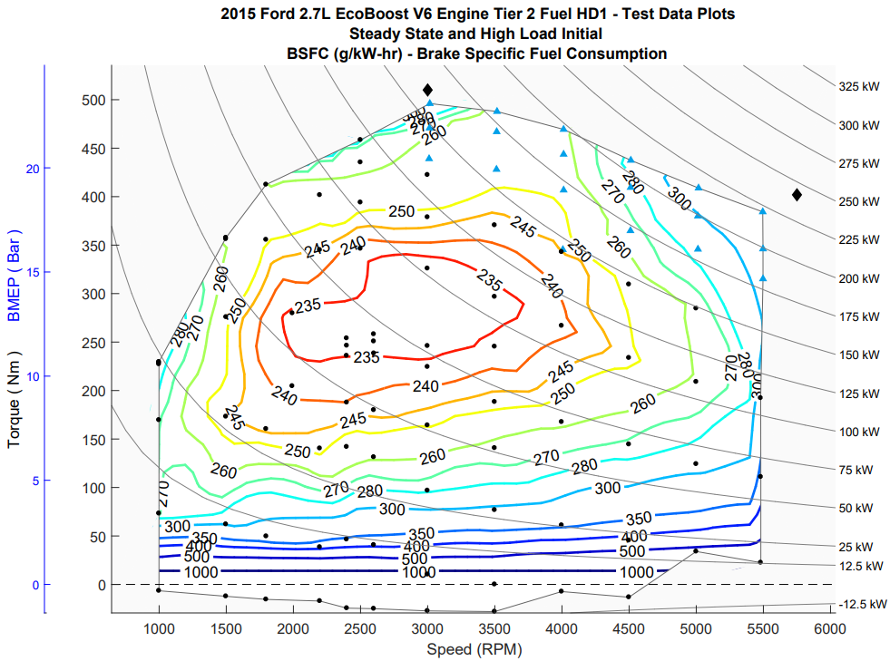
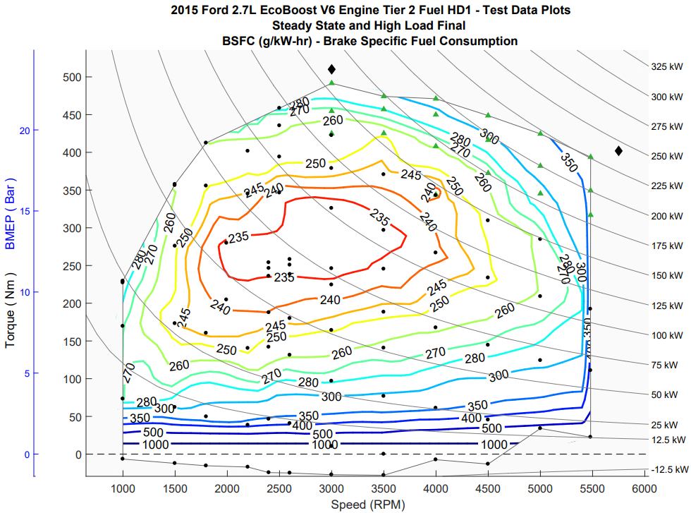
Figure 4. BSFC (g/kWh)
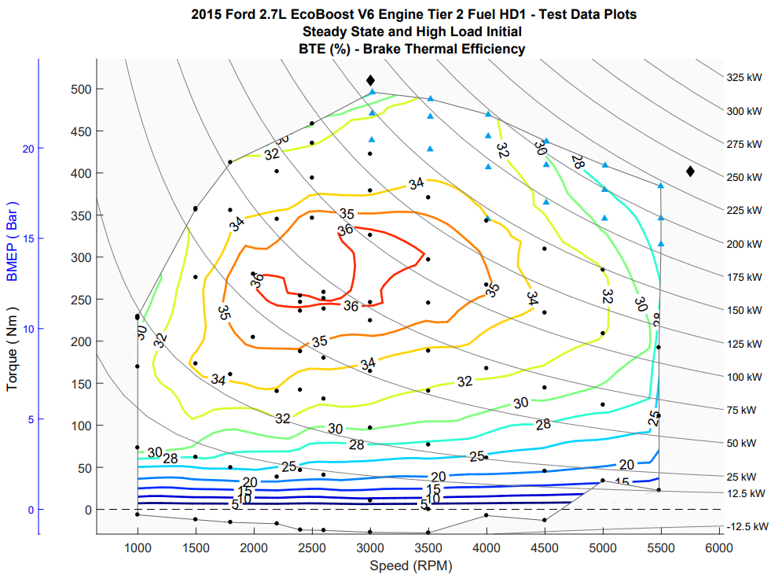
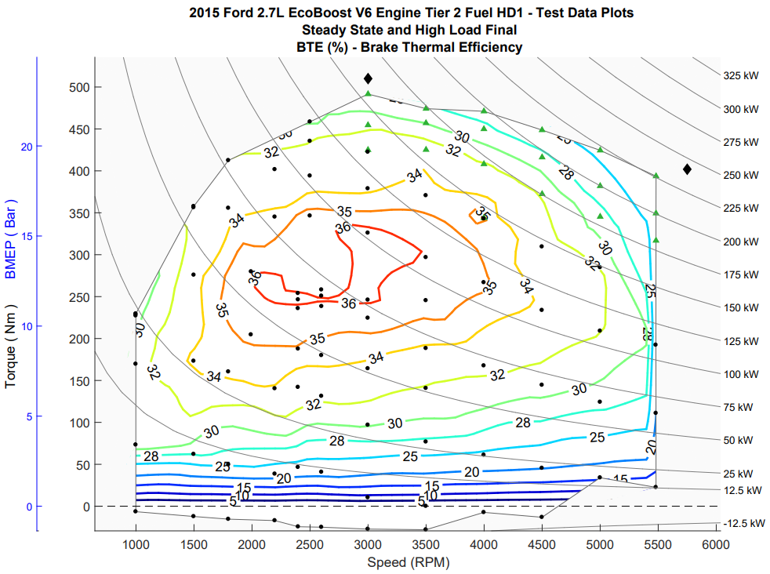
Figure 5. BTE (%)

Uncertainty
The steady-state points obtained in this testing were used primarily to establish consistency with previous data taken in a lower powered test cell as described in 2015 Ford 2.7L EcoBoost V6 Engine Tier 2 Fuel Cell 9 – Test Data Package. Thus, uncertainty for this testing was calculated only for the high load transient points. Because of the nature of the test process and the operation of the engine in this region, the variation of the sensor signals during operation are considered the primary source of uncertainty.

Sensor/Signal Uncertainties
The uncertainties of the signals [u(signal)] in the data set can be based on (a) the uncertainty associated with the calibration standard, (b) the uncertainty of the sensor calibration [u(calibration)], and (c) the uncertainty of the signal during operation [u(operation)]. The uncertainty associated with the calibration standard is assumed to be negligible when compared to other uncertainties and thus this uncertainty is not considered for this calculation.

To determine the uncertainty of the sensor calibration, past calibration records were assessed and the difference between the standard and measured quantities were used to calculate uncertainty. The calibration uncertainty for each signal is given in Table 8.

Table 8: Standard Uncertainties for Signals
Signal | u(calibration)
Speed (rpm) | 0.637
Torque (Nm) | 1.591
Fuel (g/sec) | 0.00581

To determine the uncertainty of the signal during operation, the standard deviations for each signal were calculated from the testing data and the average was used to calculate the variance of the mean, and thus the uncertainty,
$u=σ/{\sqrt{n}}$
Where n is the number of data points in the recorded mode. Both the standard deviation and the number of data points vary from mode to mode. The standard uncertainty from each signal can be calculated as the geometric sum of the calibration and operation uncertainties; i.e.:
$$u\left(signal\right)=\sqrt{{\left[u(calibration)\right]}^{2}+{\left(σ/{\sqrt{n}}\right)}^{2}}$$

Uncertainty of BSFC
The total uncertainty for the BSFC measurements is thus calculated by:

$$u\left(BSFC\right)= \sqrt{{\left(\frac{∂BSFC}{∂q}\right)}^{2}{\left[u\left(q\right)\right]}^{2}+{\left(\frac{∂BSFC}{∂T}\right)}^{2}{\left[u\left(T\right)\right]}^{2} +{\left(\frac{∂BSFC}{∂ω}\right)}^{2}{\left[u\left(ω\right)\right]}^{2} }$$
or
$$u\left(BSFC\right)= BSFC\sqrt{\left[{\left(\frac{u\left(q\right)}{q}\right)}^{2}+{\left(\frac{u\left(T\right)}{T}\right)}^{2}+{\left(\frac{u\left(ω\right)}{ω}\right)}^{2}\right]}$$

Where the individual uncertainties are calculated as shown above.

Uncertainty of BTE
The derivation of the uncertainty of thermal efficiency is similar. The uncertainty in measurement of the fuel heating value is assumed to be small compared to other uncertainties. Assuming u(HV) = 10 BTU/lb,

$$u\left(EFF\right)= EFF\sqrt{\left[{\left(\frac{u\left(q\right)}{q}\right)}^{2}+{\left(\frac{u\left(T\right)}{T}\right)}^{2}+{\left(\frac{u\left(ω\right)}{ω}\right)}^{2}+3.1*{10}^{-7}\right]}$$

Standard uncertainties (including the uncertainty of the BSFC) are analogous to standard deviations, such that it would be expected that, for a given set of data, the “true” value of a parameter would fall within +/-1u_{c} for 68% of the data points, the “true” value of a parameter would fall within +/-2u_{c} for 95% of the data points, and the “true” value of a parameter would fall within +/-3u_{c} for 99.7% of the data points. The calculated uncertainty for both the BSFC and BTE measurements is shown in Figures 7 and 8 for the high load transient points.

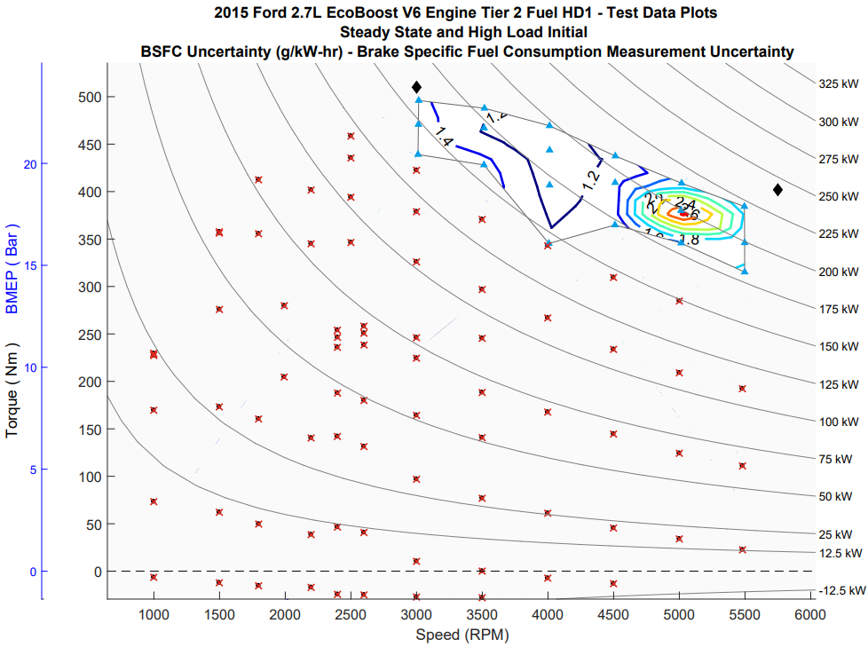
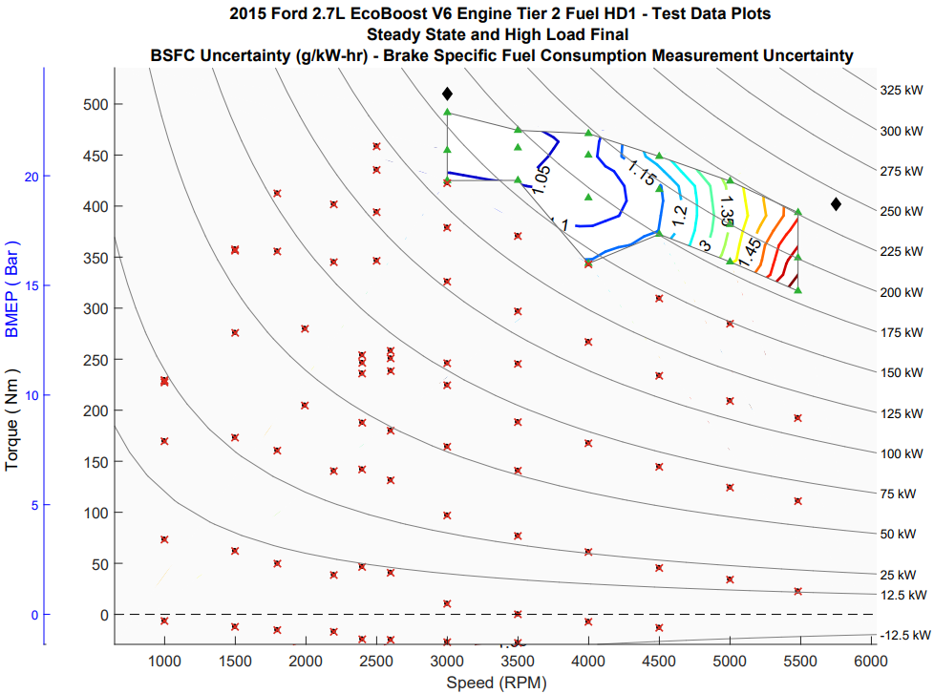
Figure 7. BSFC Uncertainty: High Load Initial (Top) and Final (Bottom)
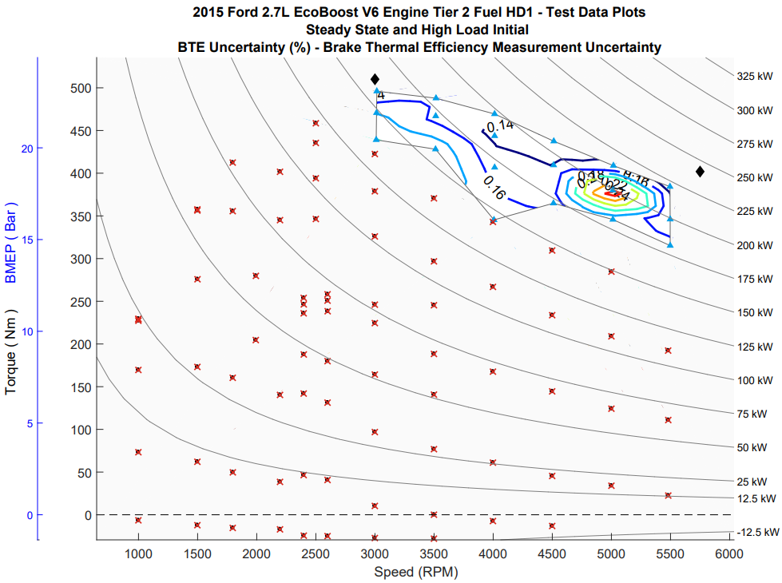
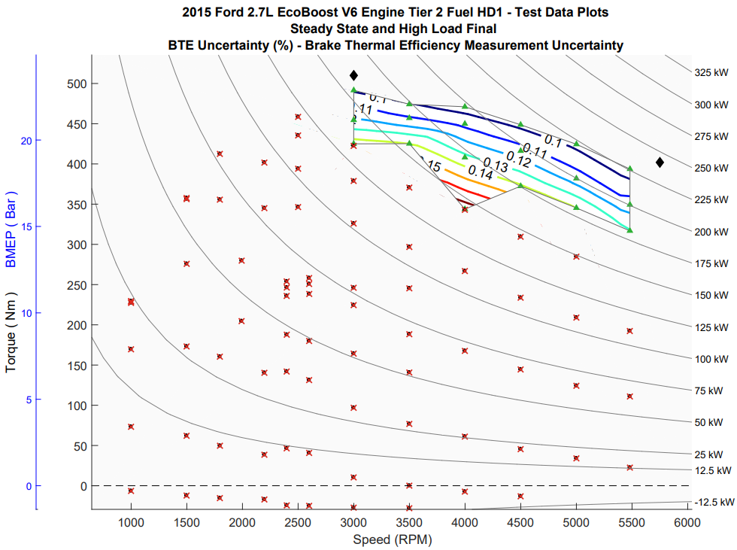
Figure 8. BTE Uncertainty: High Load Initial (Top) and Final (Bottom)

References
[1] 2015 FORD F-150 TECHNICAL SPECIFICATIONS. (n.d.). Retrieved from https://media.ford.com/content/dam/fordmedia/North%20America/US/2015_Specs/2015_F150_Specs.pdf

